# RDBMS and SQL Assignment (part 1)

**Assignment 1:** Analyze a given business scenario and create an ER diagram that includes entities, relationships, attributes, and cardinality. Ensure that the diagram reflects proper normalization up to the third normal form.

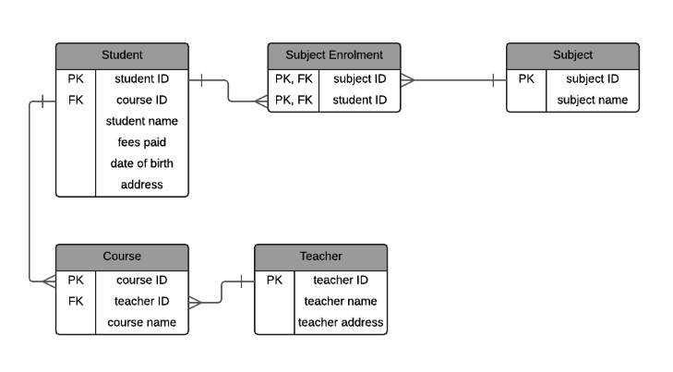

**Assignment 2:** Design a database schema for a library system, including tables, fields, and constraints like NOT NULL, UNIQUE, and CHECK. Include primary and foreign keys to establish relationships between tables.

**Step 1:**

Create a table with columns as BID, BNAME, Price and purchase Date

**Syntax : create table tablename (column_1 datatype, column_2 datatype,….column_n datatype);**

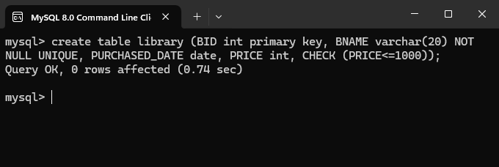

**Step 2:**

Insert values in the table which has been created using the above code

**Syntax : INSERT INTO TableName (column_1, column_2…….column_n);**

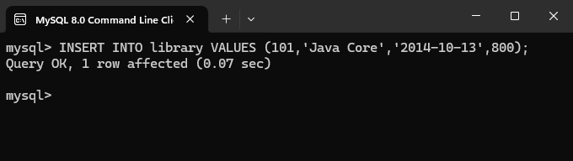

**\*NOTE: we can insert multiple rows using below code.**

**Syntax : INSERT INTO TableName (column_1, column_2…….column_n),**

**(column_1, column_2…….column_n),**

**(column_1, column_2…….column_n);**

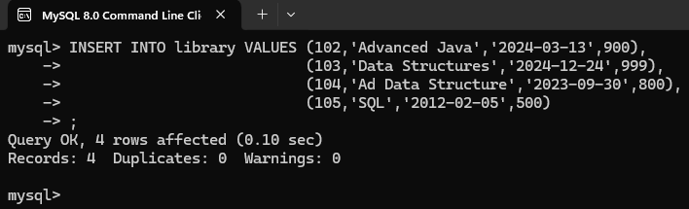

**Step 3:**

Using **SELECT** command display the table.

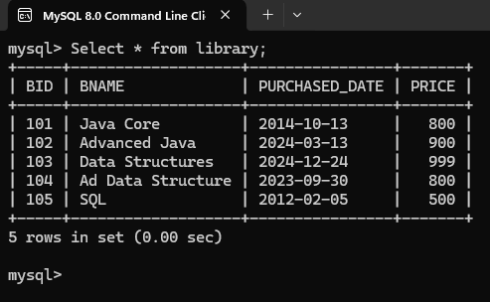

**Step 4:**

Create a new table "billing" and add primary key, Foreign key and references from library in the table.

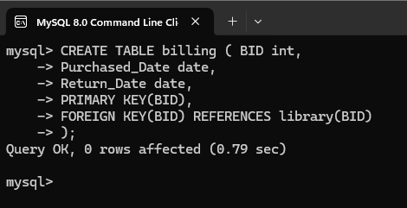

**Step 5:**

Insert values in the second table

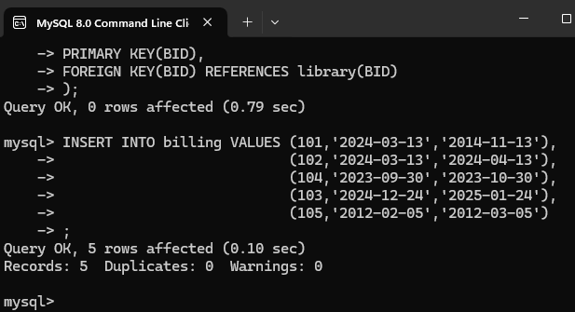

**Step-6:**

**Display all values of billing table.**

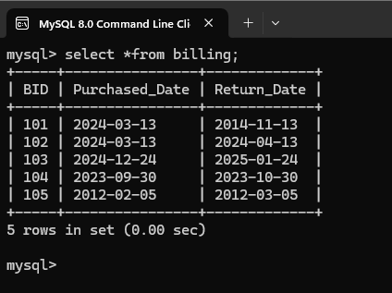

**Assignment 3:** Explain the ACID properties of a transaction in your own words. Write SQL statements to simulate a transaction that includes locking and demonstrate different isolation levels to show concurrency control.

**ACID Properties :**

In Database data is managed and that data should remain integrated when any changes are made. It’s because if the integrity of data is affected, whole data will get affected or corrupted. Therefore we need to maintain the integrity of the data, for that there are 4 properties described in DBMS. Those properties are called ACID properties

**They are as follows:**

1. **Atomicity**
2. **Consistency**
3. **Isolation**
4. **Durability**

1. **Atomicity:**

The term atomicity refers that the data remains atomic. Means if any operation is performed on the data, either it should perform or execute completely or should not be performed at all. So that the operation should not stop or break in middle.

Example: if a person is sending money on internet to his friend, but due to some network issue the transaction has been stopped. So the whole transaction is stopped or reverted back to original. So that the persons money won’t get lost.

1. **Consistency:**

The word consistency means that the data should be remain preserved. That means if a change is made to the data it should remain preserved always. So that the data remains consistent before and after transaction. So the data will always be correct.

Example: if multiple transactions are made by the person the data should be consistent after each transaction. Else the bank would be in trouble.

1. **Isolation:**

The word Isolation refers to separation. Isolation the property of database where no data should affect the other one. That means if a transaction of one database should start when the transaction on the first database gets complete.

Example: if 2 persons having their transactions separately then their data should not effect each other.

1. **Durability:**

Durability refers to that the data after the successful execution, the data should remain permanent in the database for any time. That is known as Durability in Database.

**Assignment 4:** Write SQL statements to CREATE a new database and tables that reflect the library schema you designed earlier. Use ALTER statements to modify the table structures and DROP statements to remove a redundant table.

**Step 1:**

To create a new Database we use create command.

**Syntax: CREATE DATABASE database_name;**

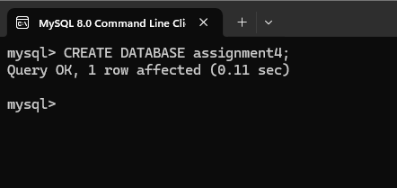

**Step 2:**

Connect to the created database

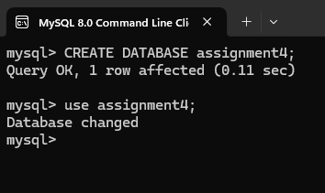

**Step 3:**

Create new table and copy the library table in it.

**Syntax: CREATE TABLE as (sub query);**

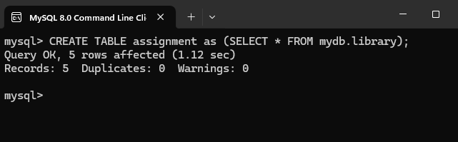

**Step 4:**

Display the table which was copied from another table.

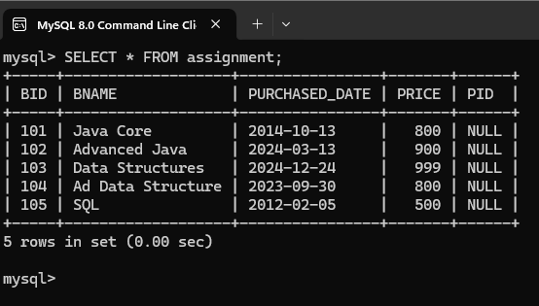

**Step 4:**

Use alter command to modify the table structure, here we used drop command to delete column in the table.

**Syntax: ALTER TABLE table_name DROP COLUMN column_name;**

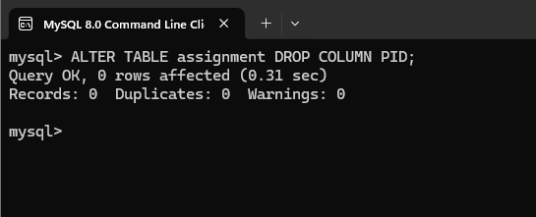

**Step 5:**

**Check if the column deleted successfully.**

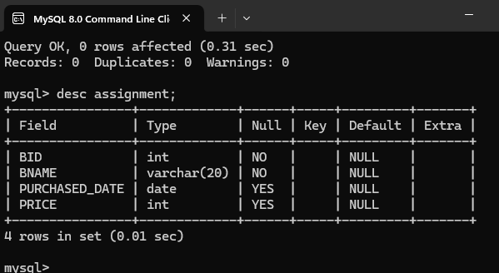

**Assignment 5:** Demonstrate the creation of an index on a table and discuss how it improves query performance. Use a DROP INDEX statement to remove the index and analyze the impact on query execution.

**Index:**

In SQL index helps to access and retrieve data faster than usual. But updating or modifying data is slow. Indexing helps for large amount of data, so that data can be retrieved faster.

**Syntax: CREATE INDEX index_name ON table_name(column1,column2…);**

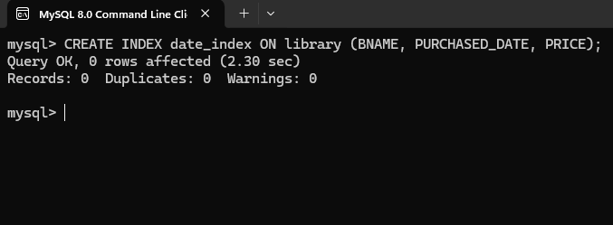

**DROP INDEX:**

Since small data can be accessed directly and fast we use DROP INDEX.

**Syntax: ALTER TABLE table_name DROP INDEX index_name;**

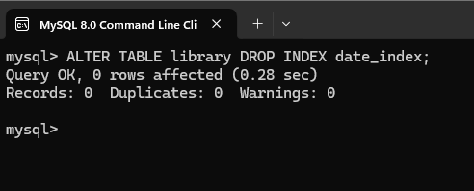

**Assignment 6:** Create a new database user with specific privileges using the CREATE USER and GRANT commands. Then, write a script to REVOKE certain privileges and DROP the user.

In mysql to view all users the following command is used:

**Syntax: select user from mysql.user;**

To create new user the following syntax is used:

**Syntax: CREATE USER user_name@localhost;**

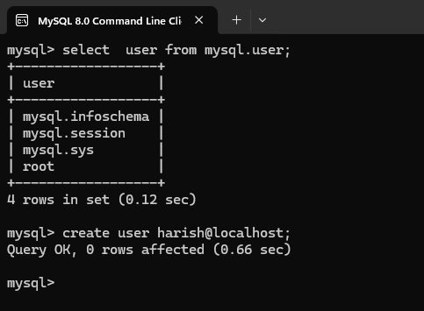

**Assignment6:** Create a new database user with specific privileges using the CREATE USER and GRANT commands. Then, write a script to REVOKE certain privileges and DROP the user.

**Grant permissions to the user**

**Syntax: GRANT ALL PRIVILEGES ON database_name.*TO 'username'@'localhost;**

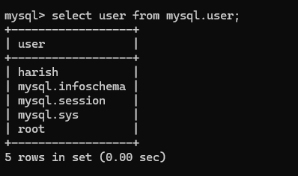

**DROP USER:**

To drop a user the following syntax is used

**Syntax: DROP USER user_name@localhost;**.

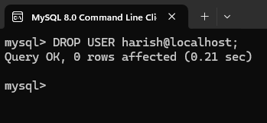

After dropping user from the database

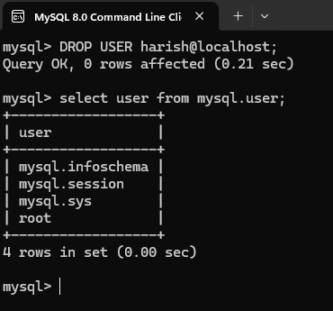

**Assignment 7:** Prepare a series of SQL statements to INSERT new records into the library tables, UPDATE existing records with new information, and DELETE records based on specific criteria. Include BULK INSERT operations to load data from an external source.